Estancia Palo Santo

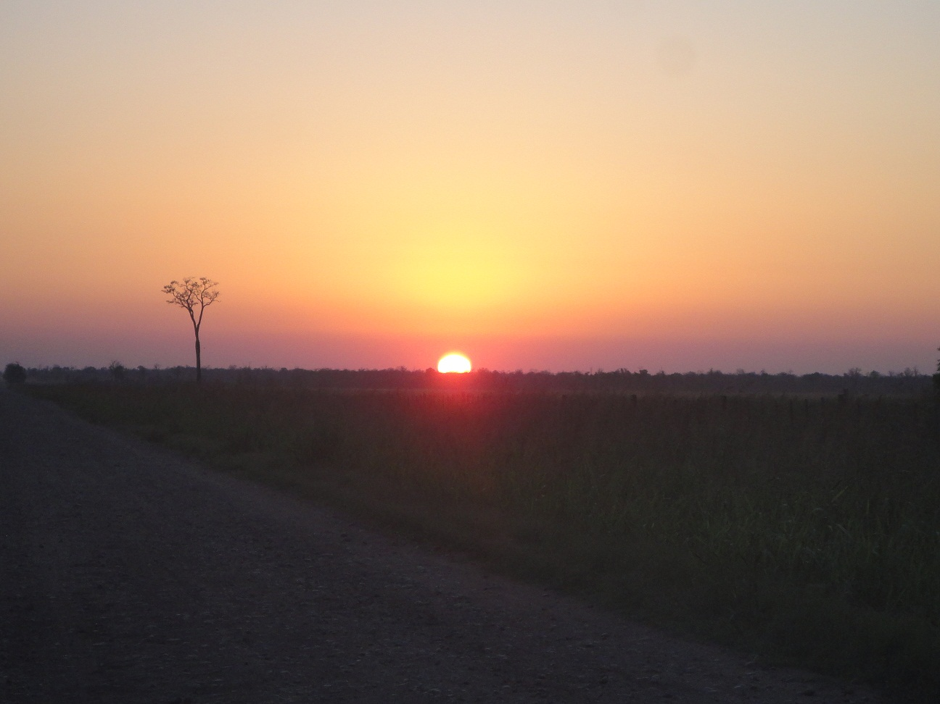

Province: Salta

Department: Rivadavia

Deeded Hectares : 4,000 hectares(10,000 acres)developed land and 24,000 hectares(60,000 acres) of forest land to be developed. Total Aproximately 28,000 or 70,000 acres, no lease acres.

Location: 100 km(60 miles) east of Tartagal, Salta, Argentina

Average rainfall: 600 mm or 24 inches per year

Current Stocking Capacity 2,500 cows with their calves and bulls or 6.000 heifers

Future Stocking Capacity once all 28,000 has have been developed is 17,500 cows, row crops are also possible to be planted

80 km(48 miles) of Boundary fence plus 30 km(18 miles) internal fences

Water well 6 inches cased to 160 meters, 5.5 hp sub set at 120 feet(40 meters) producing 75 gallon per minute or 17.000 litres per hour.

4.000 hectares cleared and planted with gatton panic, Texas buffel and rhodes grama grass. Good corrrales, water system and cross fences.

Lots have been stacked with Brush rakes, can be converted to Agriculture land with minimal investment, for black beans, corn, or grain sorghrum.

Prices: U$ 1,000 per hectare($400 per acre) developed land

U$ 400 per hectare($160 per acre) forest land

U$ 13,500,000 total

Can be divided and or sold with owner financing

Seller is willing to:

1. Partner on land and/or farming operation with buyer
2. Lease back all or part of developed farm short or long term
3. Manage developed farm and cattle operation for buyer
4. Develop remaining forest land into crop and cattle land

This is an exciting time to invest in agriculture in Argentina for 3 reasons:

1. Argentina has suffered one of their worst political systems for the past 12 years. This government was anti farm and anti business in their policies. Farm values have bottomed out under this government. In December 2015, a historic election brought in a pro business president, Mauricio Macri. He has already made changes in the foreign exchange laws and tax structure that have immediately helped the farmers and businessmen.

2.Another reason is the world prices of grains have also reached cyclical lows. A rise in grain prices will cause a rise in farm land prices.

3.Another reason is the simple fact that Salta is a frontier area. As more land is developed in the area, infrastructure (roads, lights, gas, etc) are installed making the price of the developed land rise. For example, similar land 700 miles south in a more developed area is valued more than triple, around $1,400 per acre.

Now should be a good time to lock up a large productive farm in a good area with a decent annual return and large upside potential for asset appreciation.

<http://www.wsj.com/articles/farmland-investments-take-root-1438661041>

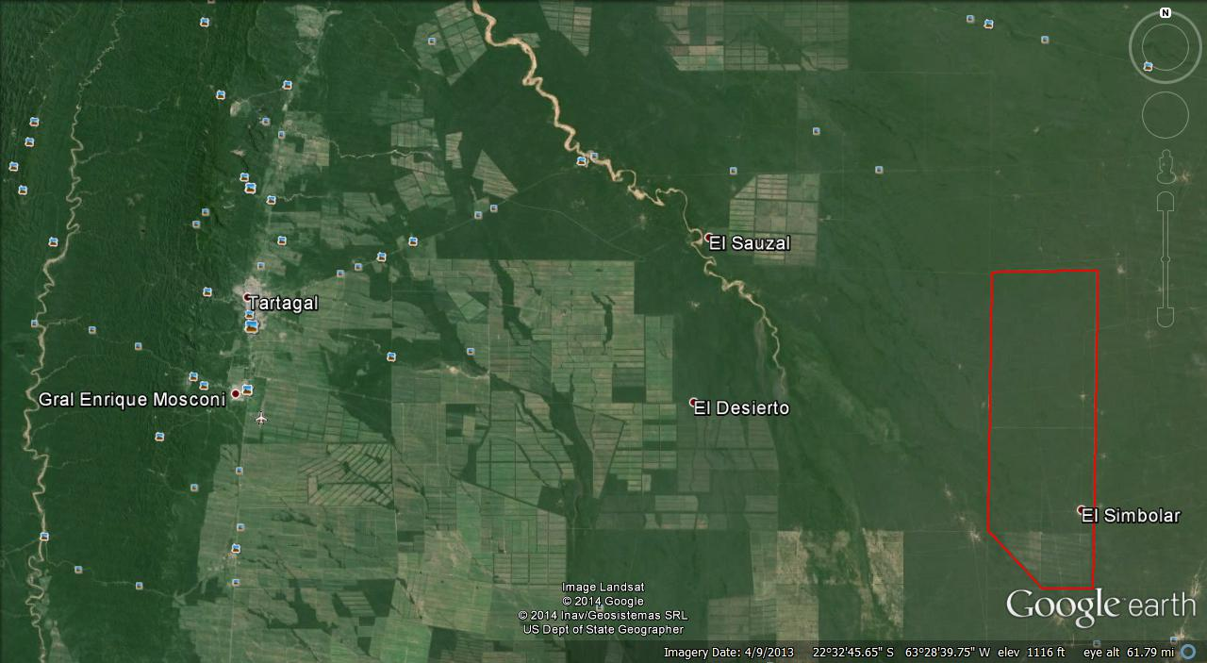

General Area of the 4.000 hectare cow farm and 24.000 hectare forest land marked in Red. Developed land on the south end, forest land to the north permits for development applied for. Paved road (Ruta 54) from Tartagal to Santa Victoria passes approximately 40 kilometers from the north boundary. Optional access is by dirt road 100 km from Gral Mosconi.

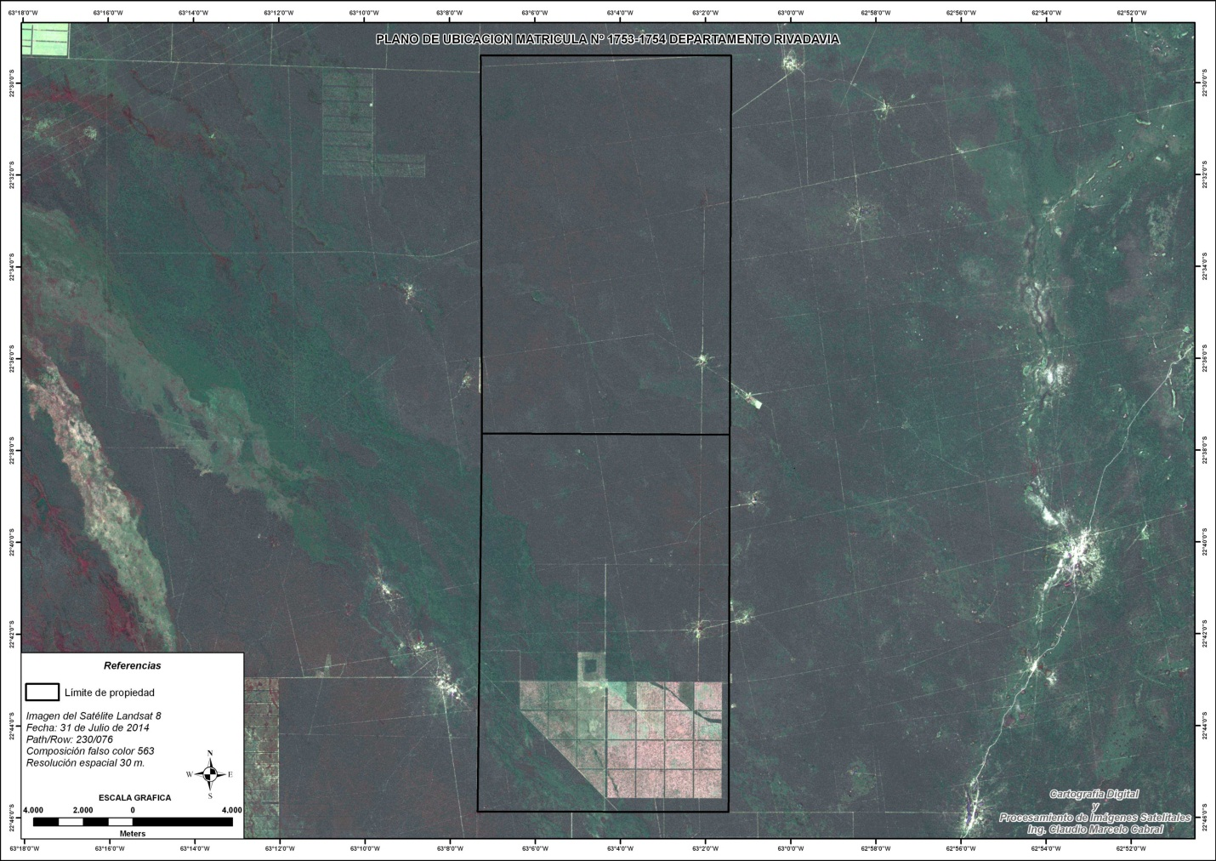

Cow Farm showing the 4.000 hectares of developed land to the south and the 24.000 hectares of forest land to the north. The southwest corner is a 5,000 acre reserve for permit purposes and is not included in the sale.

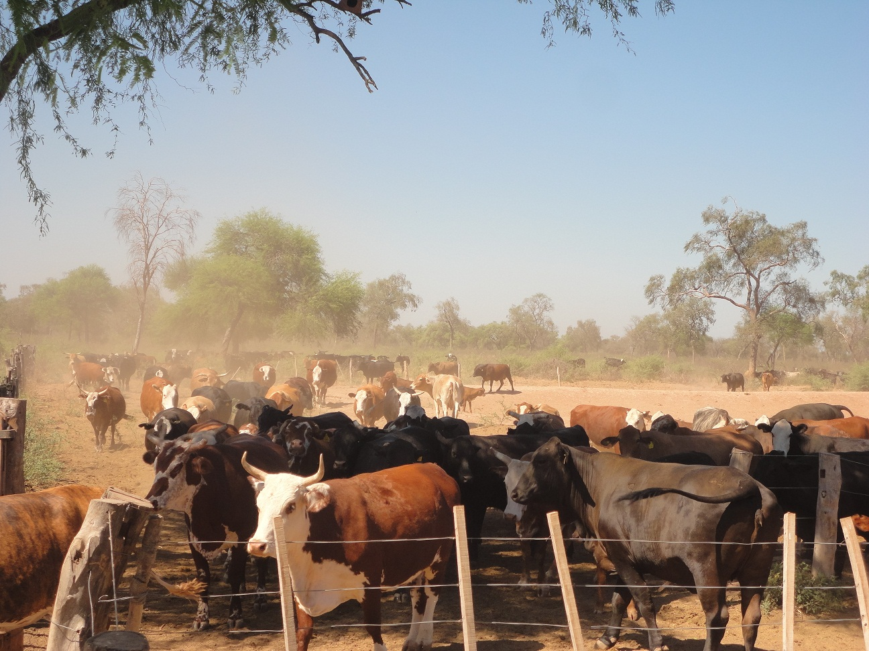

Bred cows in Winter. A brahma cross is necessary for the heat and bugs.

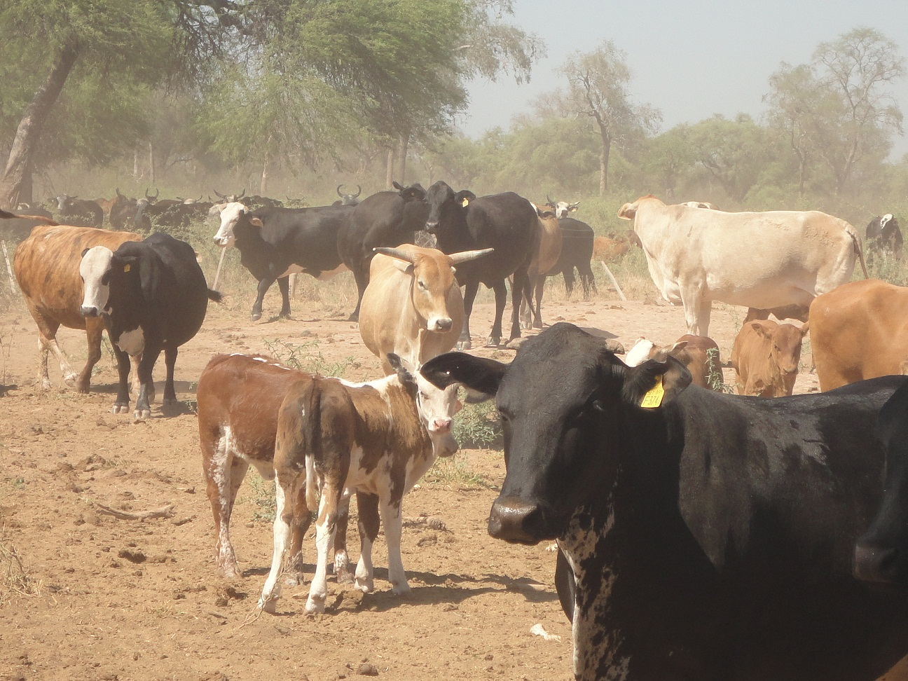

Bred and calving cows in Spring.

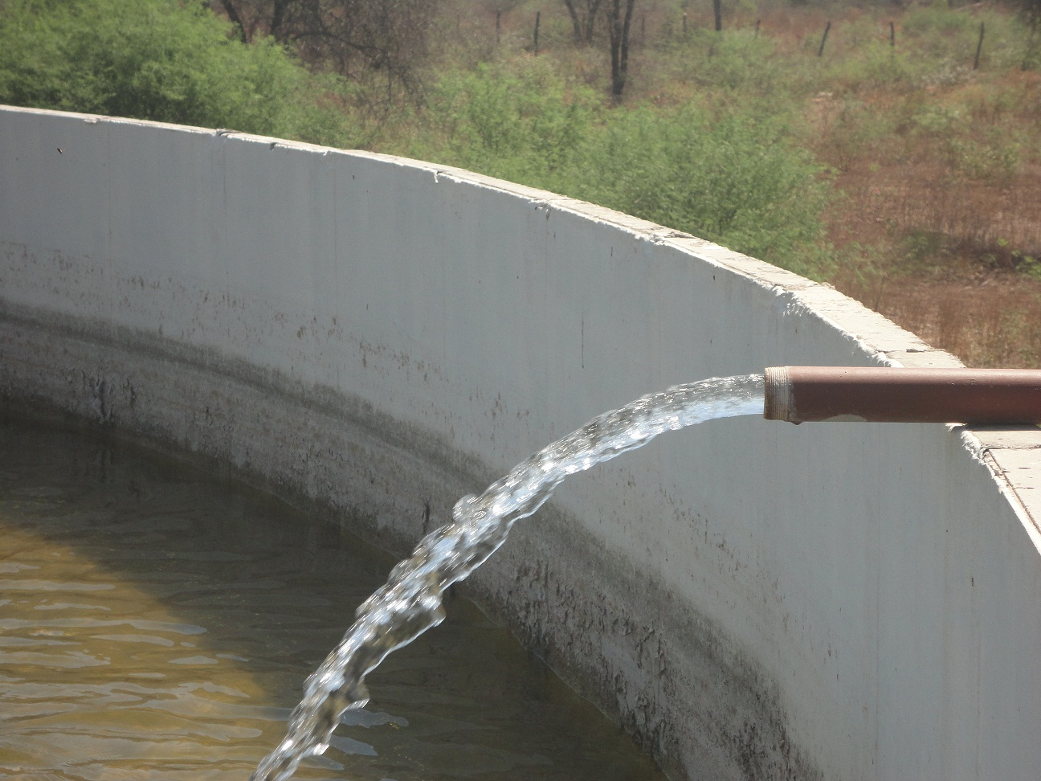

Water Well, 75 gallons per minute, 5.5 hp electric sub powered by 16 kw diesel generator. Pumping from around 120 feet.

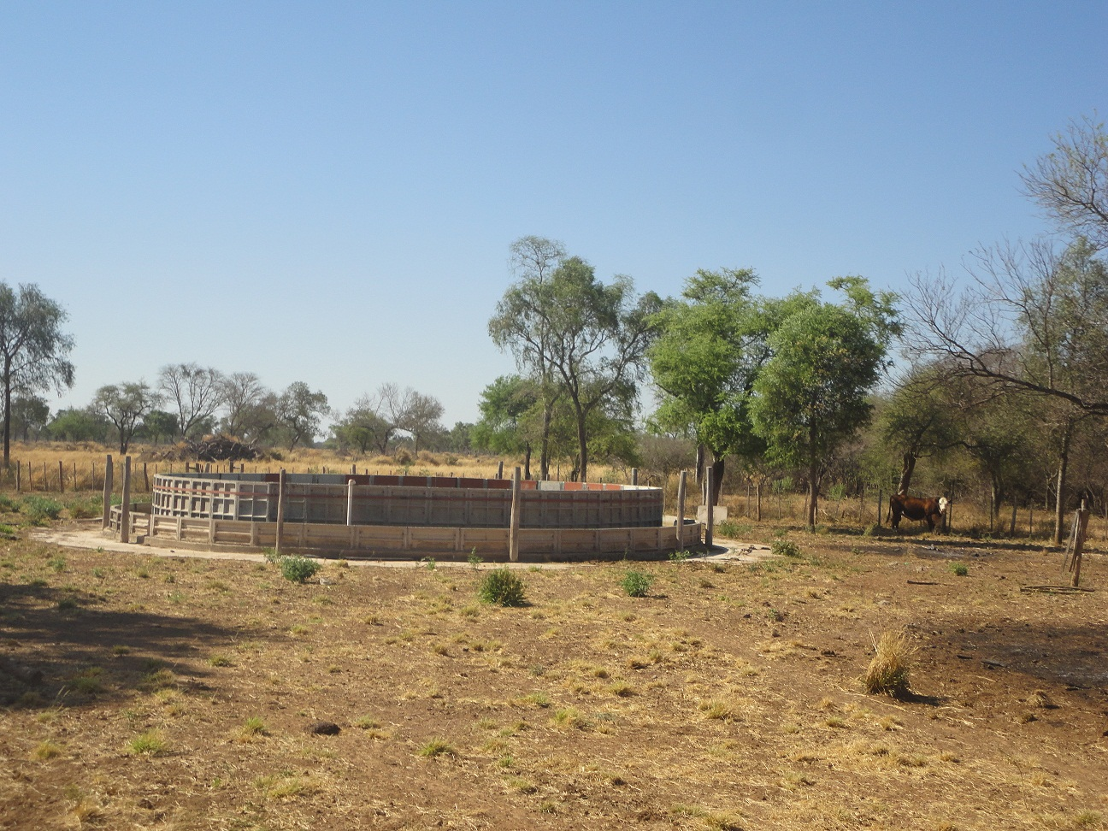

Concrete Water Storage and Drinker

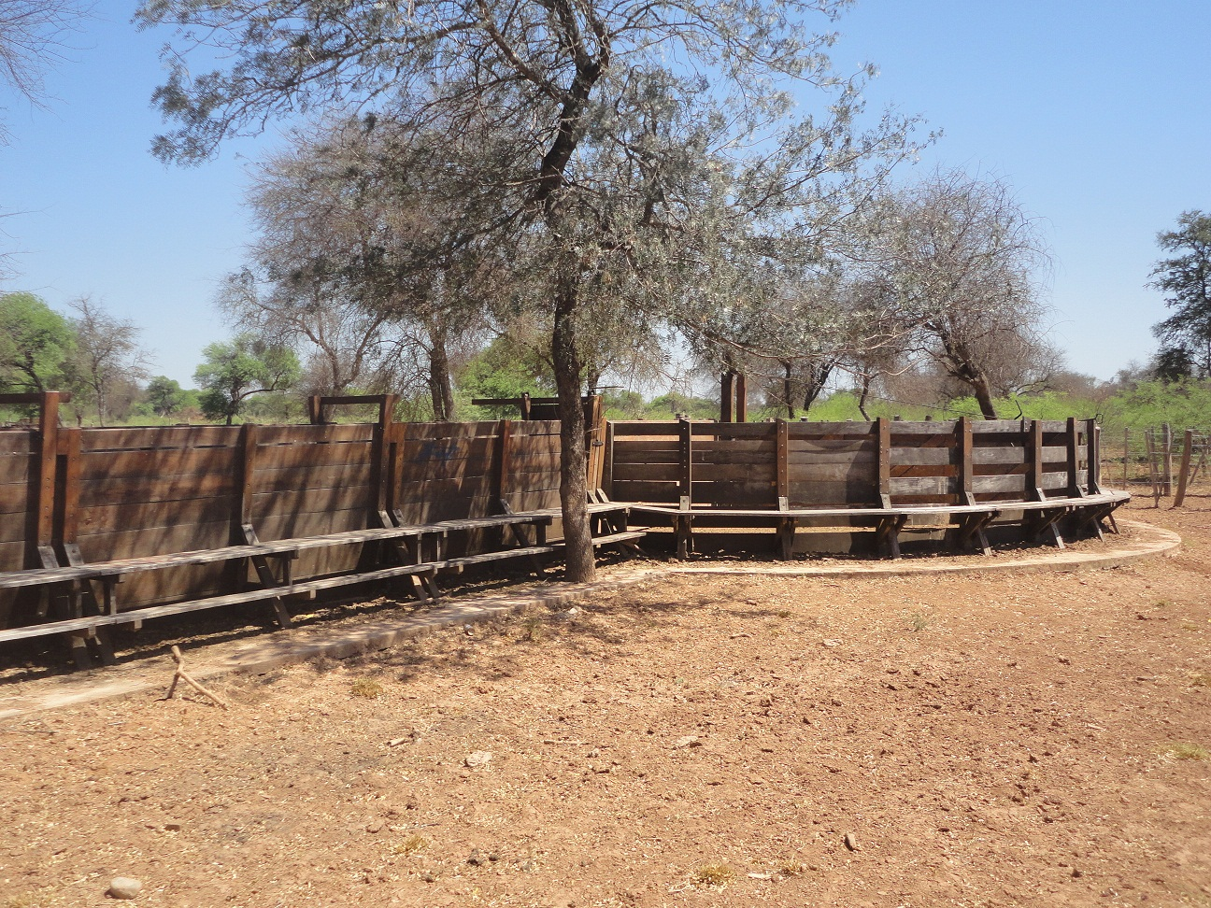

Cattle Tub

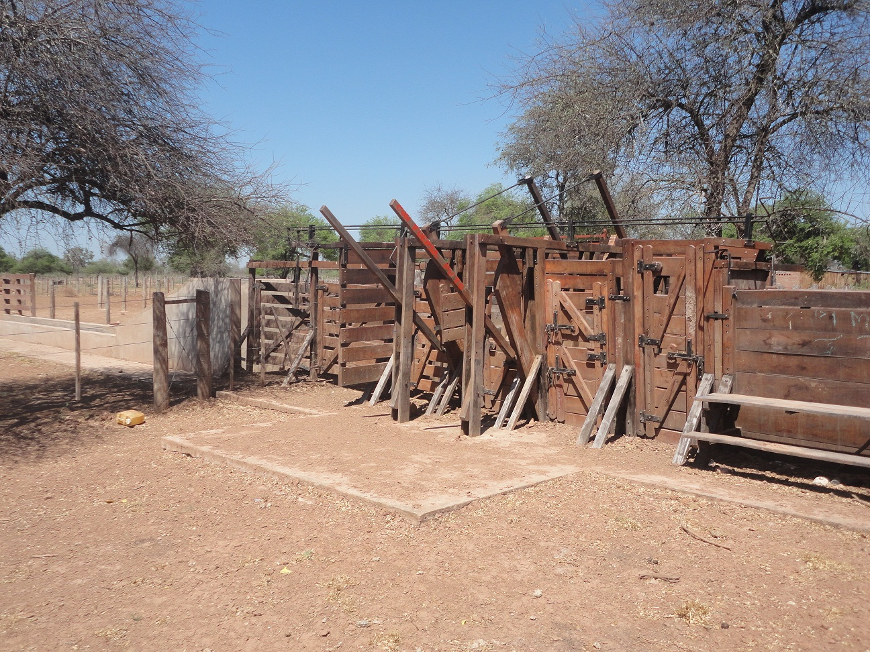

Cattle Chute

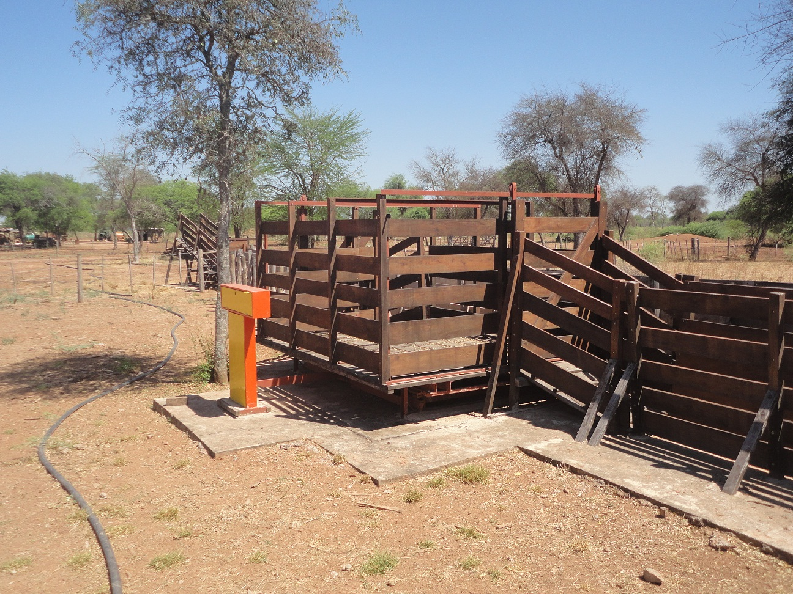

Cattle Scale

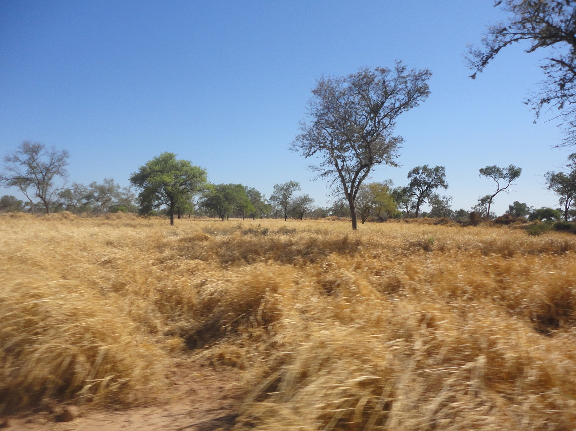

Winter Grass

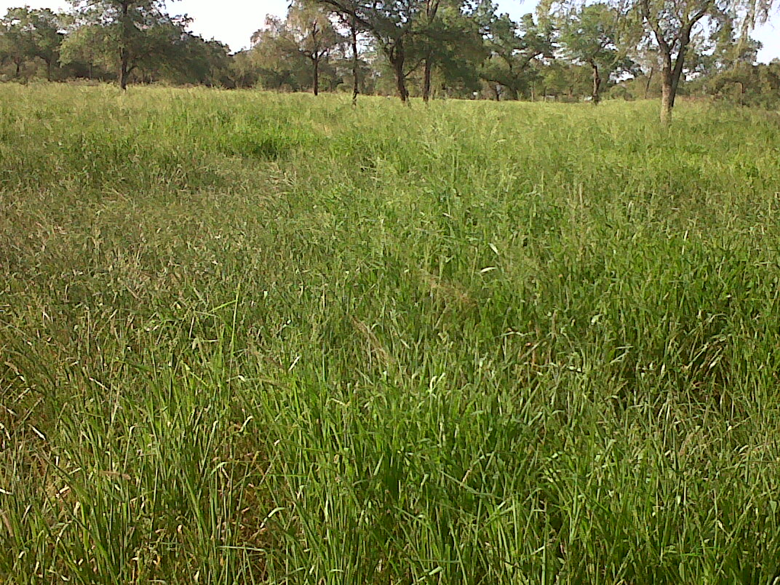

Summer Grass

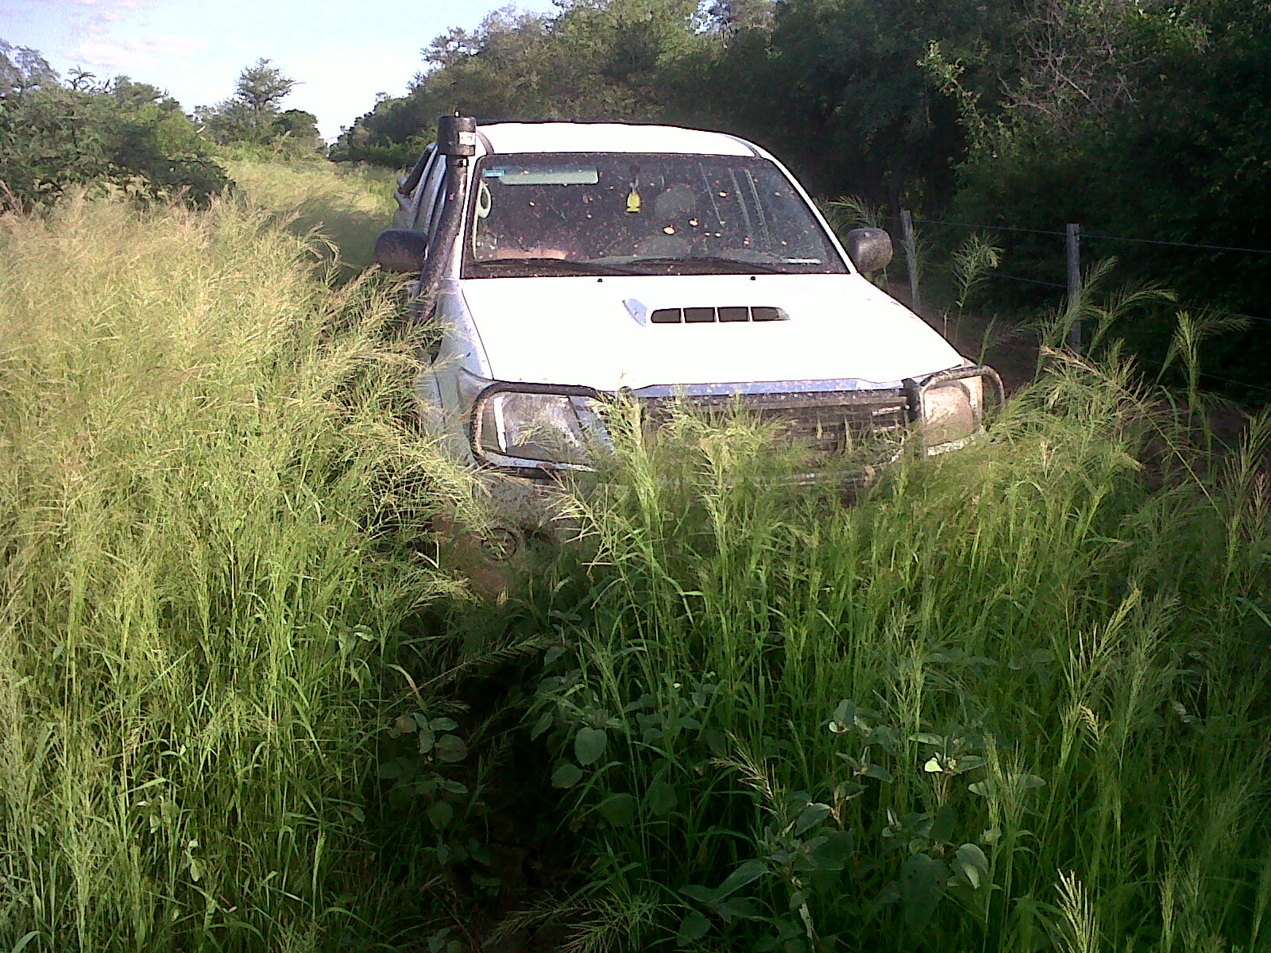

Summer Grass

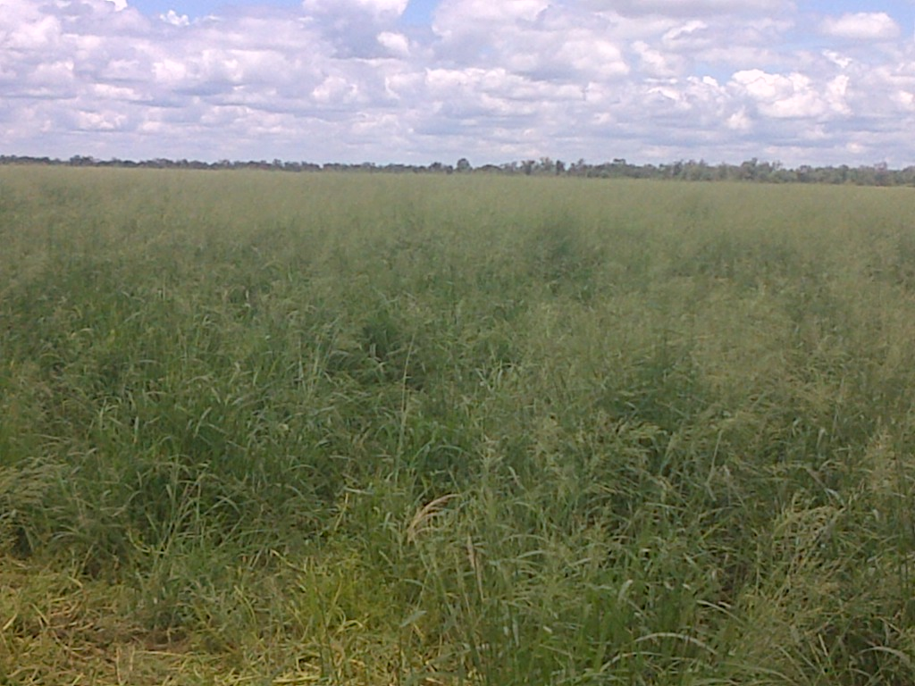

Gatton Panic