Salta Argentina Grain and Cattle Farm Project

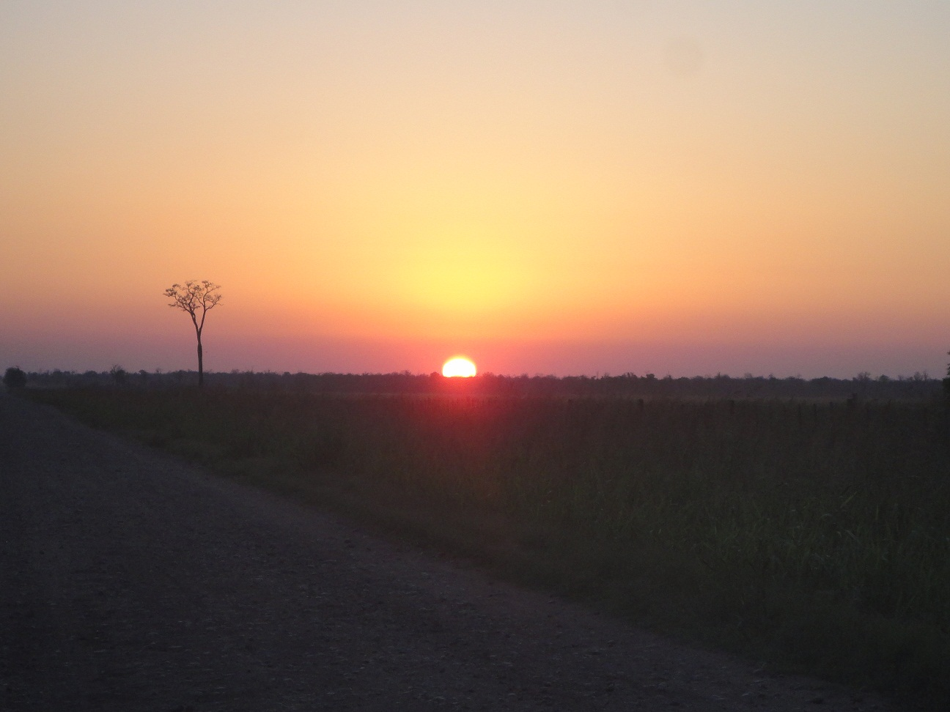
Sunrise on the Salta Plains

After selling some developed farms we have reinvested in a 13,400 hectare(33,500 acre) block of forest and brush development land in the Las Lajitas, Salta, Argentina area. This land has no problems with Indian peoples living near the farm. This is an excellent area known for corn, grain sorghum, black beans, red beans, white beans, wheat and some soybeans. It is also an excellent intensive cattle area with subtropical improved pastures such as Gatton panic, Rhodesian Grama, and Mulato grass. It has an ideal climate for cattle feeding, with dry winters and hot summers. It has excellent soils and 26 inch(650 mm) annual rainfall. The farm is located 10 miles (16km) from a paved highway by way of a rock road.
We have paid the development permit fees for the next 33,500 acre block and work can begin immediately. The current permit process requires that 35% of the land be left in forest reserve for wildlife habitat. This reserve land can be used for cattle grazing and hunting.

The finished 33,500 acre farm would include:
- All of the forest removal and soil preparation explained in the pictures(dozer work, deep chisel, heavy disc, and all hand labor, etc)
- 1 owners house
- 3 division houses
- 3 barns
- 6 water wells
- 10 concrete water storage tanks and drinkers
- 10 working pens
- 100 miles(160 km) approximately of permanent 5 wire fencing
- 50 miles(80 km) of internal dirt roads

The finished 33,500 acre farm would have a capacity for
- 10,000 mama cows or
- 30,000 fattening steers on grass and feedlot
- 22,000 acres of dryland dry edible bean, soybean, grain sorghum and corn production and 1,000 cows in the woodlots A mixture of the above.
Price : U$500/ hectare (U$200/acre) U$6,700,000
Seller is willing to:
- Partner on land, development, and/or farming operation with buyer
- Lease back all or part of developed farm short or long term
- Manage developed farm and cattle operation for buyer
- Develop brush land into crop and cattle land for buyer
Owner financing available
Can be divided into 4,000 hectare(10,000 acre)units
Development costs are around U$625/hectare(U$250/acre). Seller willing to develop farm for buyer or sell “turn key”
We feel this is interesting for an ag investor because of the opportunity to lock up a huge reserve of productive land at a cheap price. This land will increase in value as the development increases in the area, as we develop the land we own, grain prices go higher, and Argentinas new president, Mauricio Macri(elected in December of 2015) recuperates the lost confidence foreign investors have in Argentina.
Development cost are around U$250 per acre and a proposed development plan of 3 years, developing 10,000 acres per year.

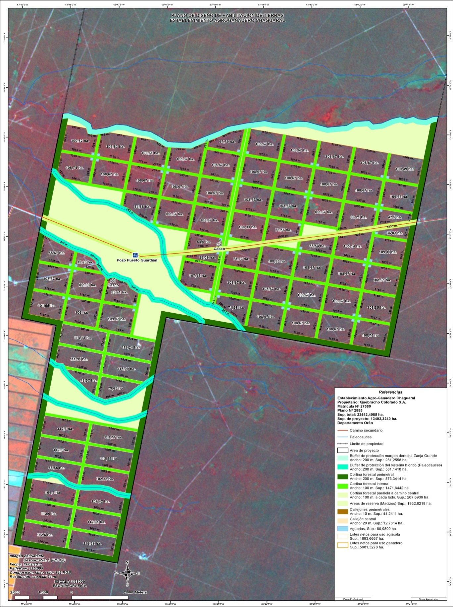
Approved permit map showing the first 13,400 hectare(33,5000 acre) division. Forest reserve land shown in tan. Individual field acreage shown in hectares, 1 ha= 2.47 acres.

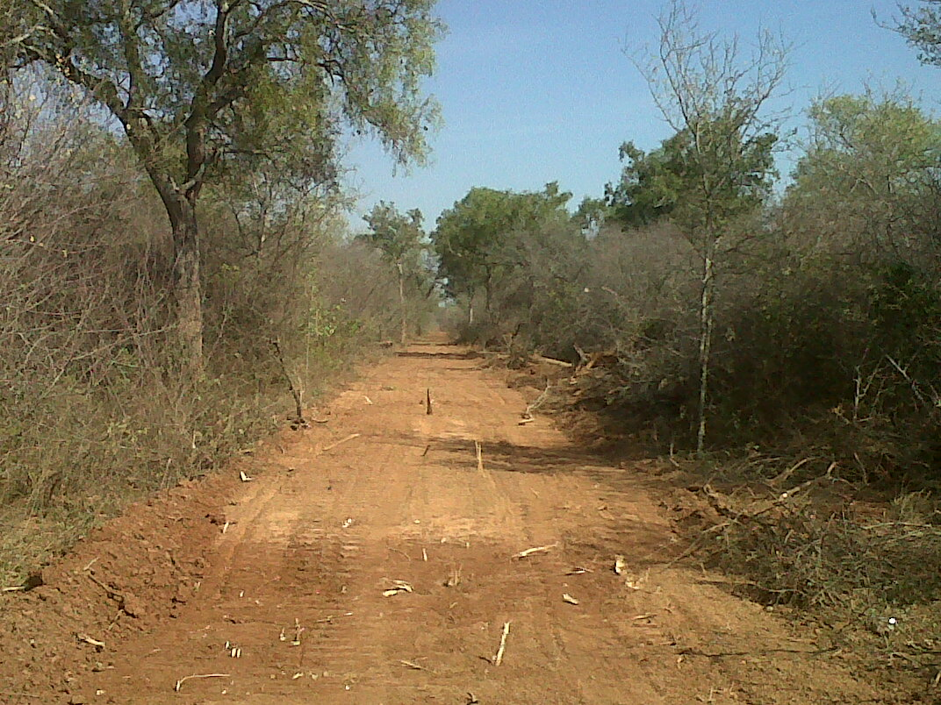
First step is mark the field with a GPS equipped D8 Cat bulldozer. This path will also be used to gain access to the job site with diesel, parts, food, etc.
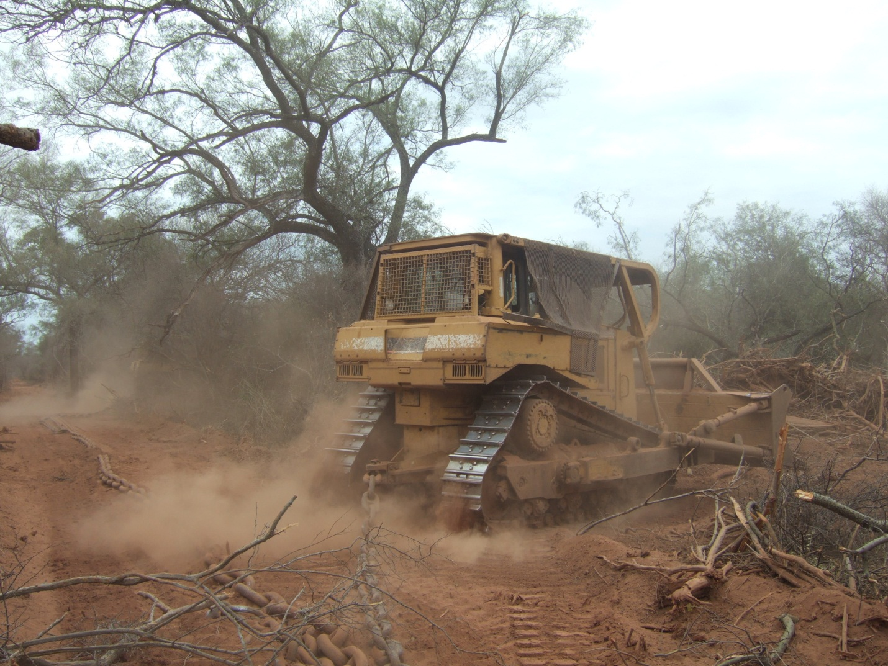
Step 2 is 2 D8s pulling 300 foot of anchor chain between them. The dozers work 100 feet apart with the chain forming a loop behind them.
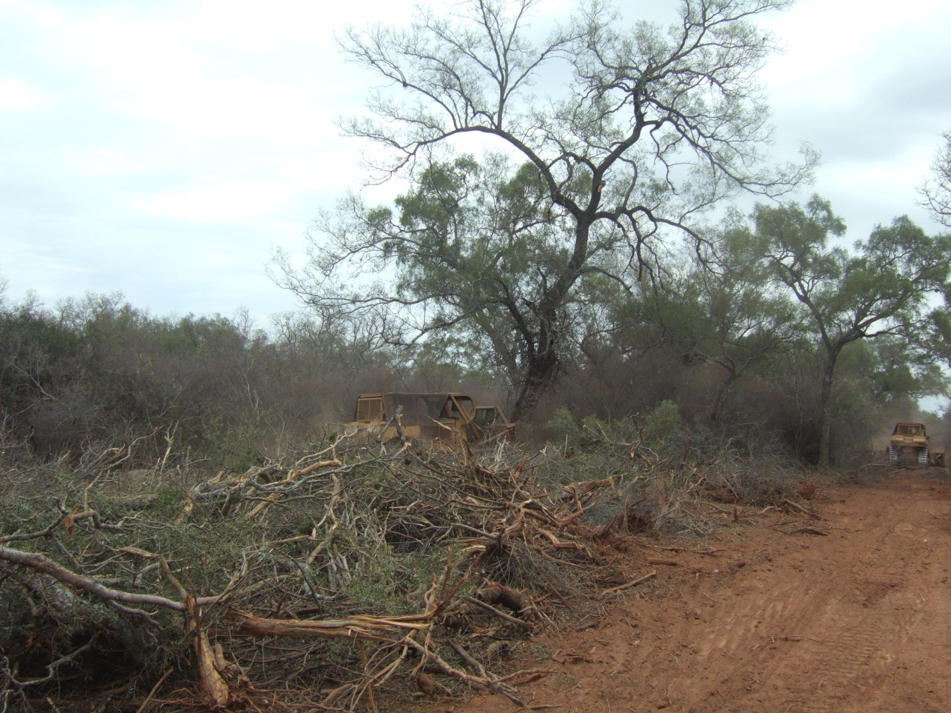
Sometimes a tree is too tough to pull down with the chain so one of the dozers backs up and pushes it over with the blade as high as possible for leverage. This forest consists of a few big trees and lots of underbrush.
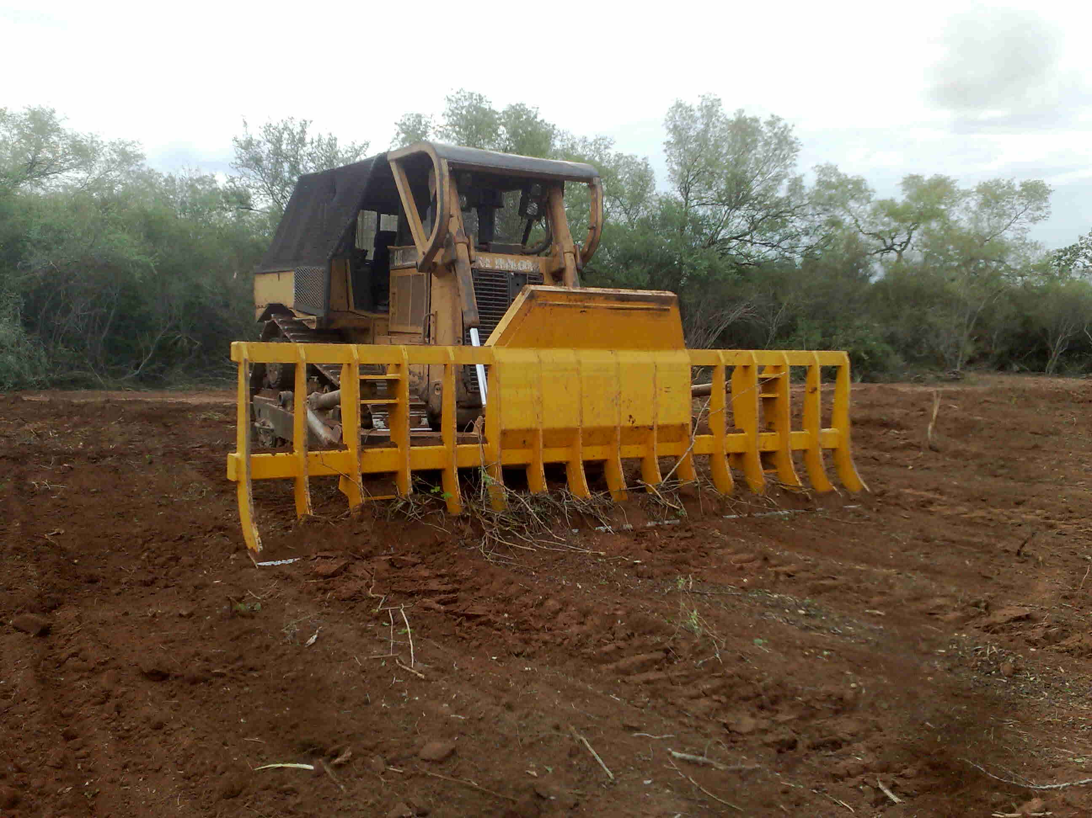
The next step is pile up the chained down brush and fallen trees in windrows with D8s equipped with brush rakes.
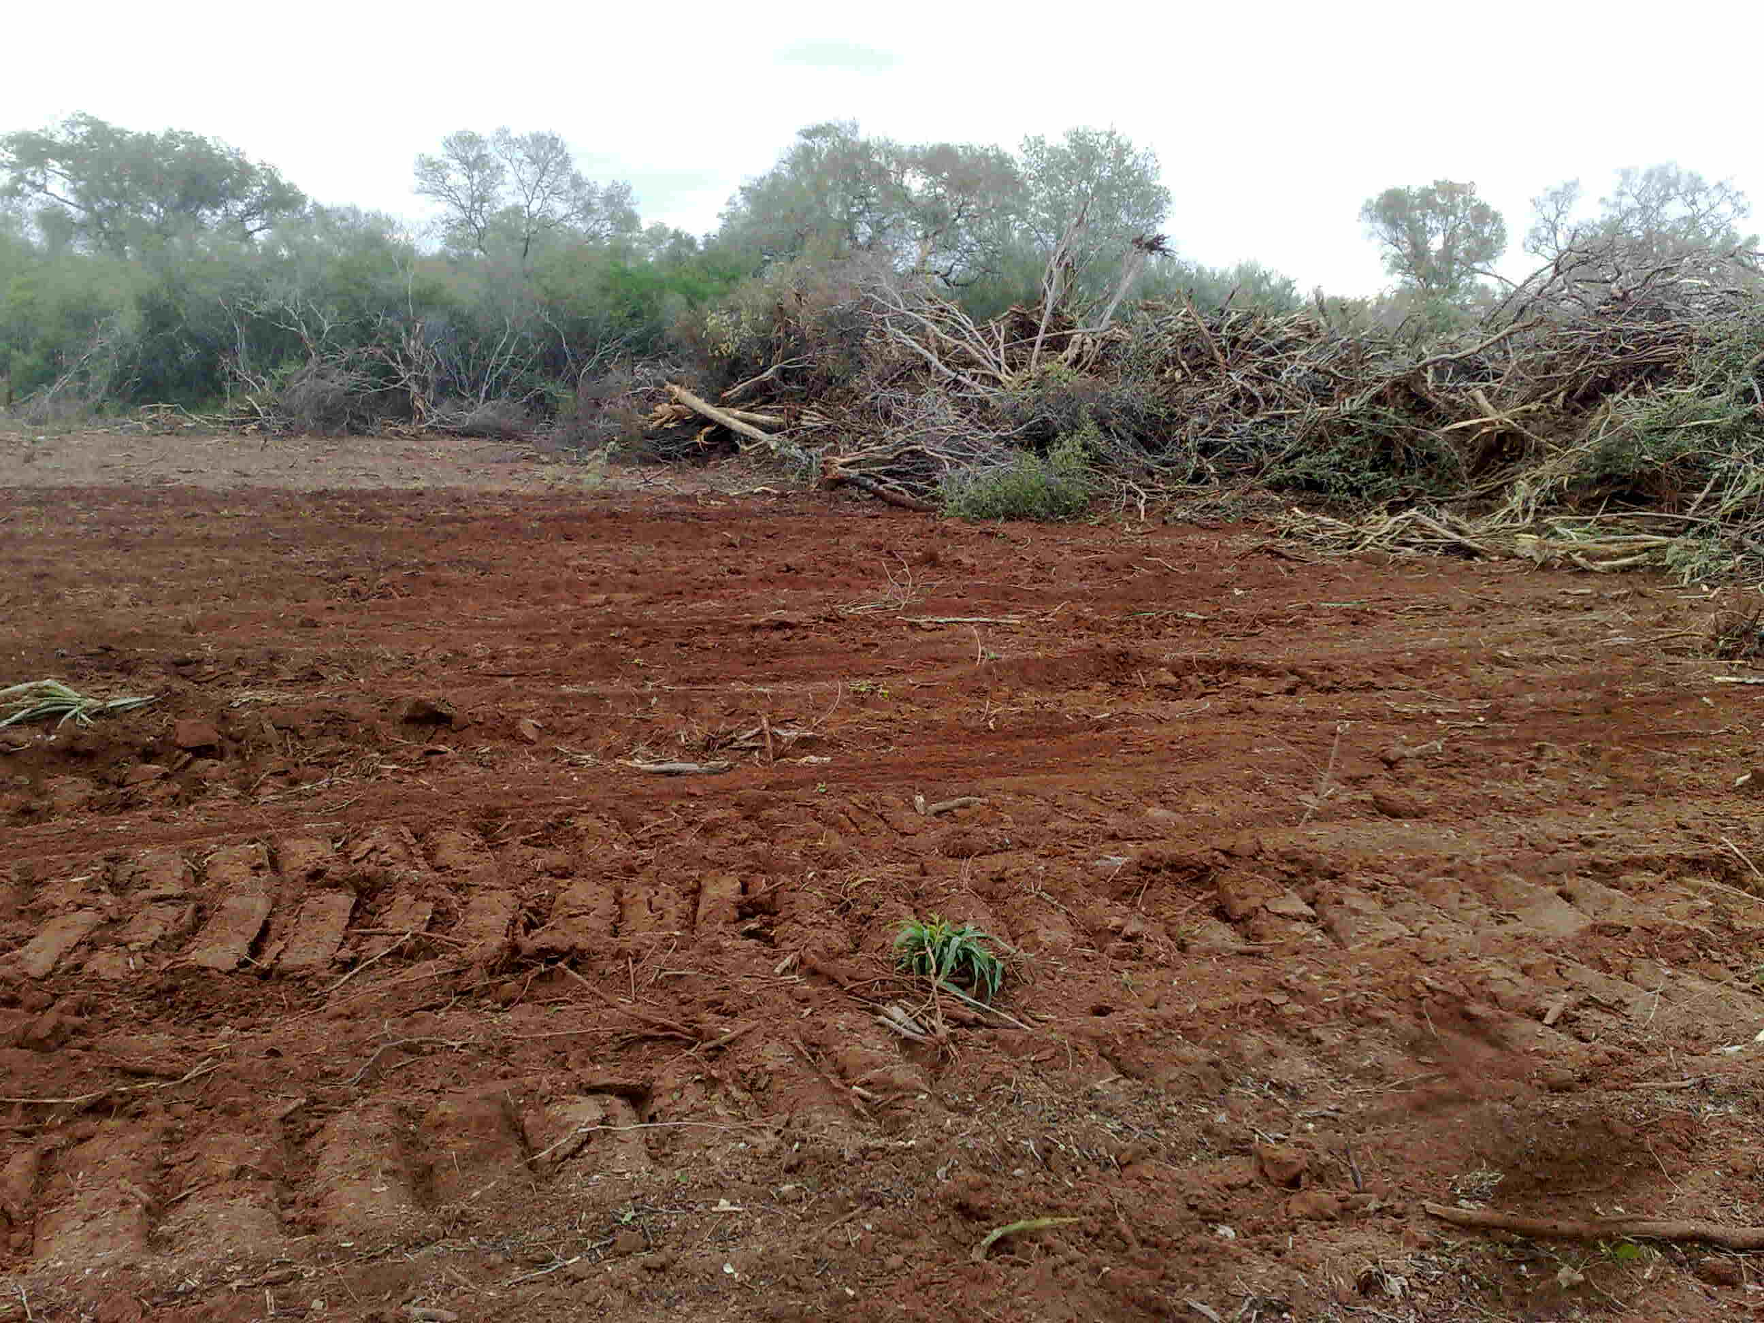
Brush windrows piled up with the brush rakes. Ideally, the rake cuts roots while pushing as little topsoil possible into the windrow. Wood useful for fence posts is removed from the windrow before burning.
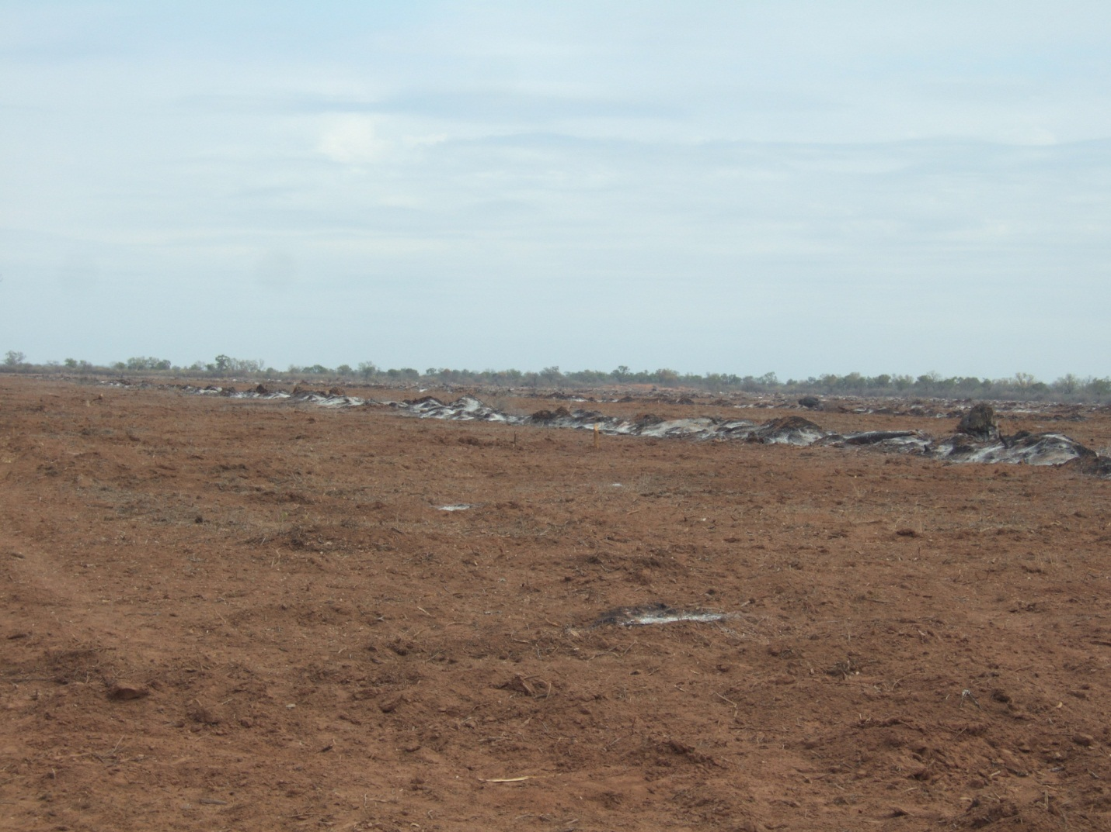
The next step is dig up stumps with axes and shovels and burn the brush windrows.
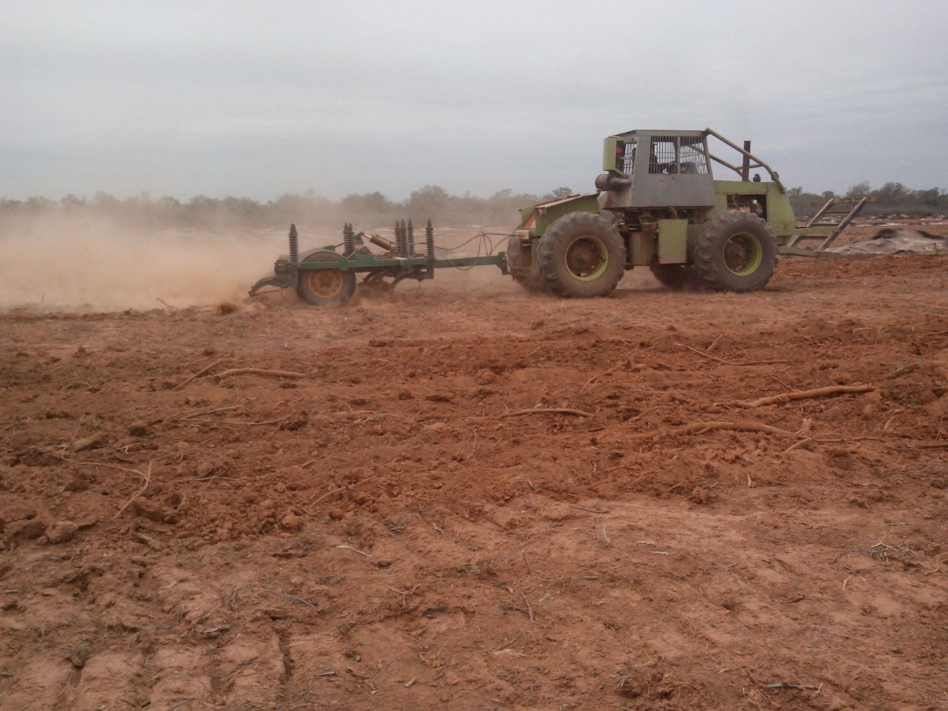
Next step is a deep chisel plow. This serves two purposes, loosens up the soil compacted by the dozers and brings to the surface all the roots that escaped the brush rakes. These roots and sticks will be piled by hand crews and burned.
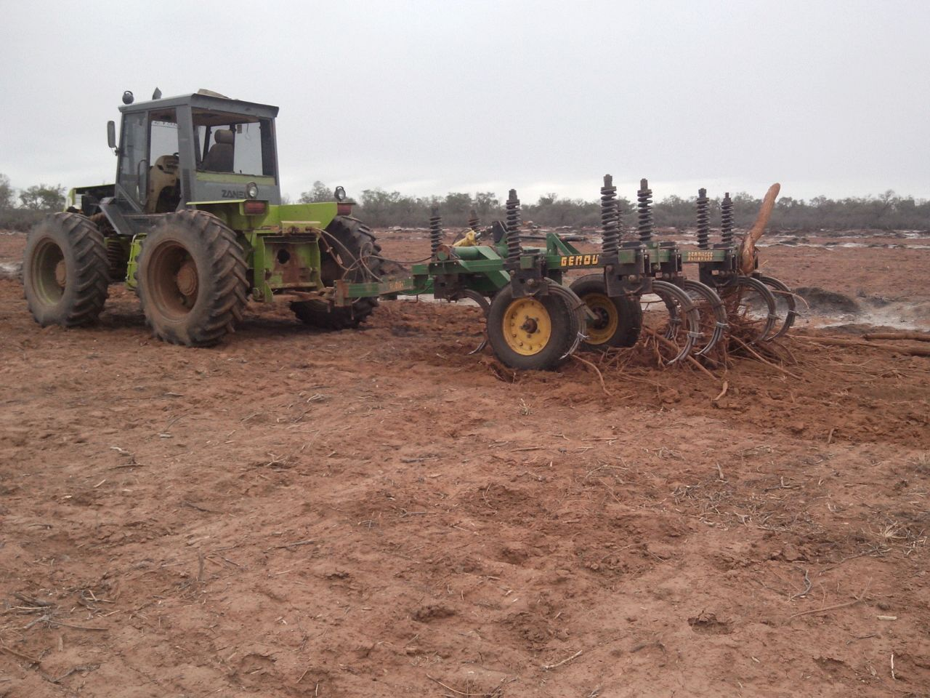
Another deep chisel plow pulling up roots and sticks.
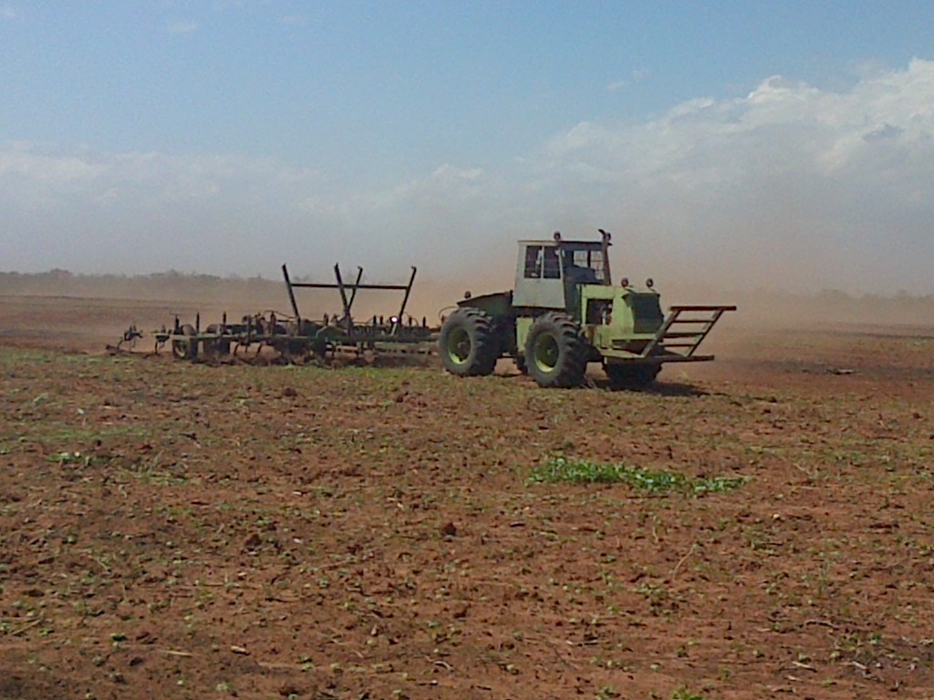
Next step pulling a sweep plow or disc plow with levelers attached behind. This will also bring some small sticks to the surface that must be piled and burned by hand crews.

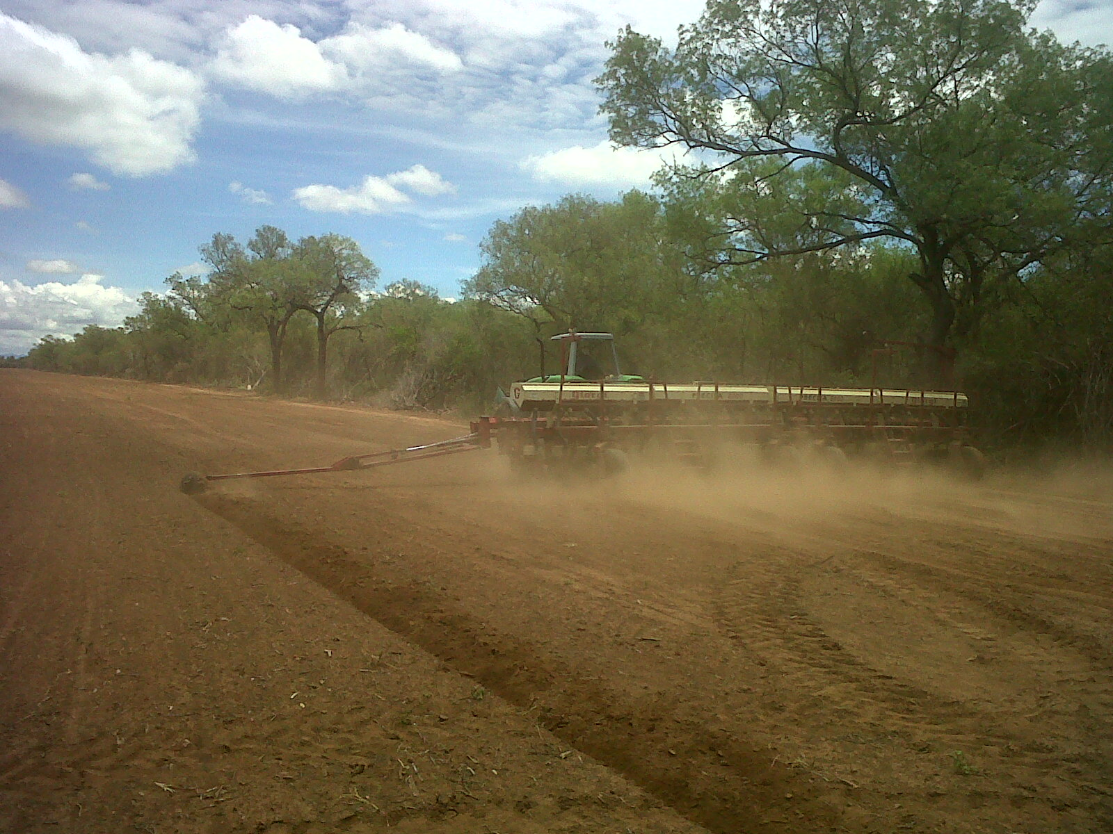
Finally the field is ready to plant dry edible beans, corn, soybeans, or improved subtropical grass with a no till planter.
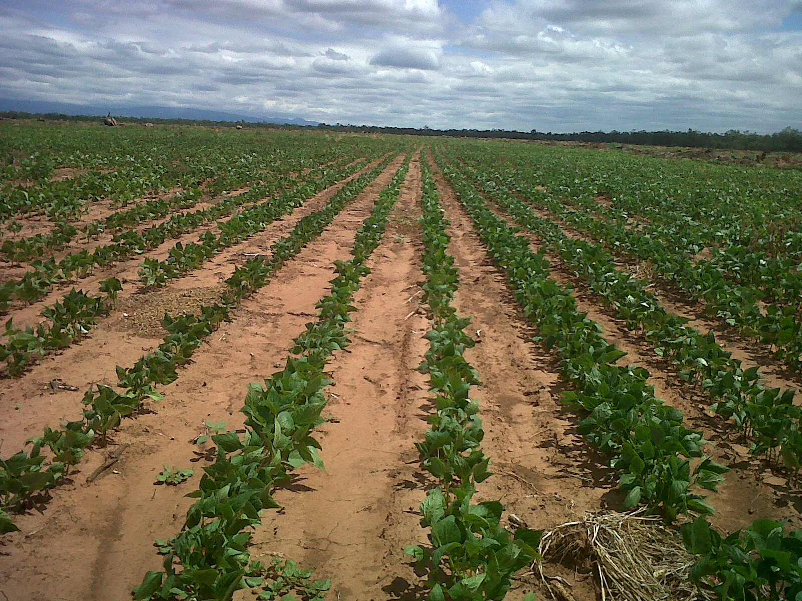
Stand of Black beans in a newly developed field.

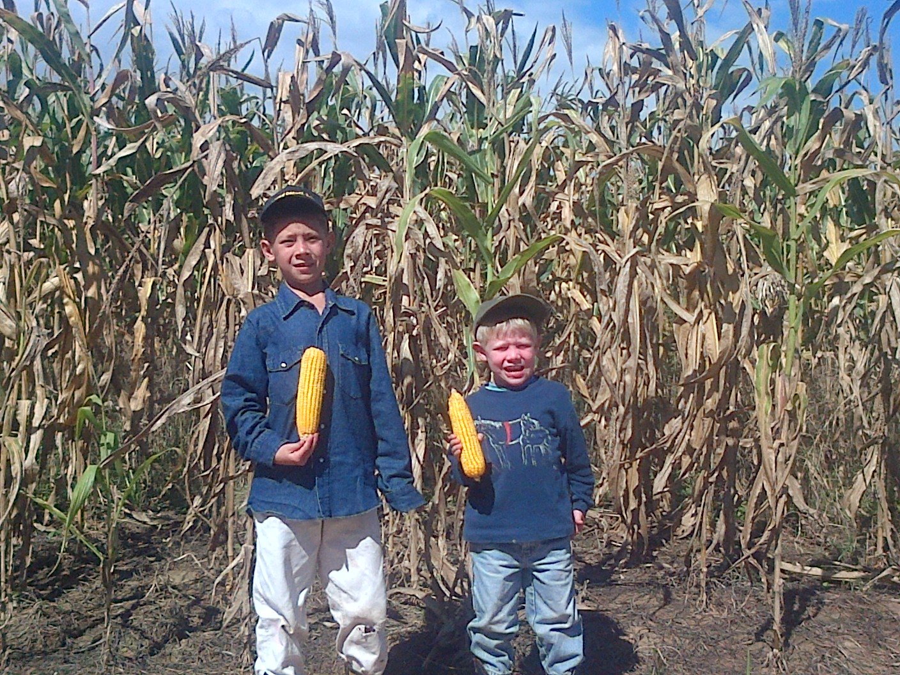
Dryland corn field.
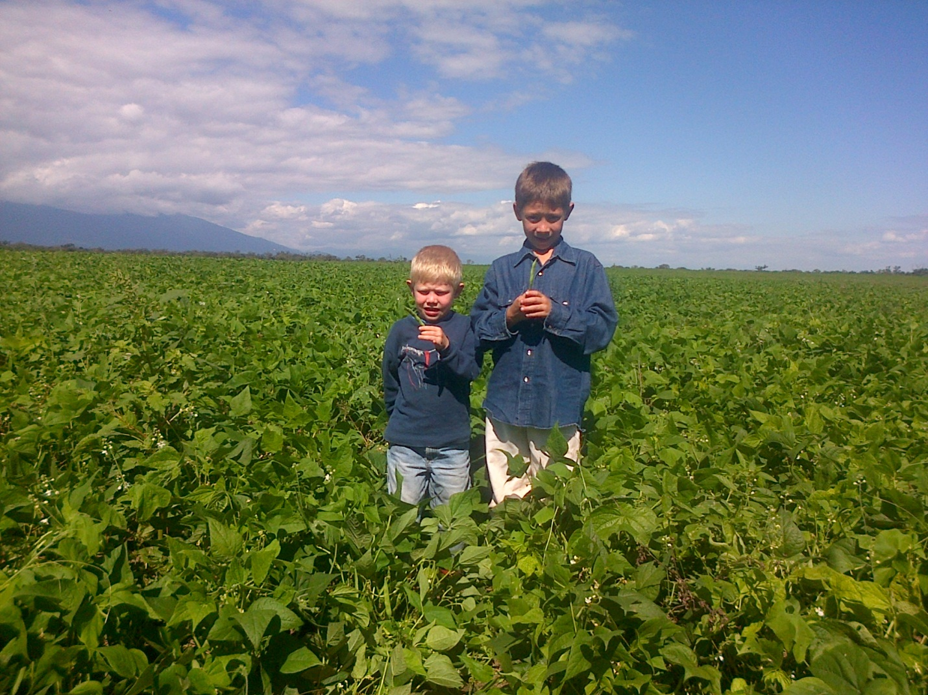
Dryland edible bean field.
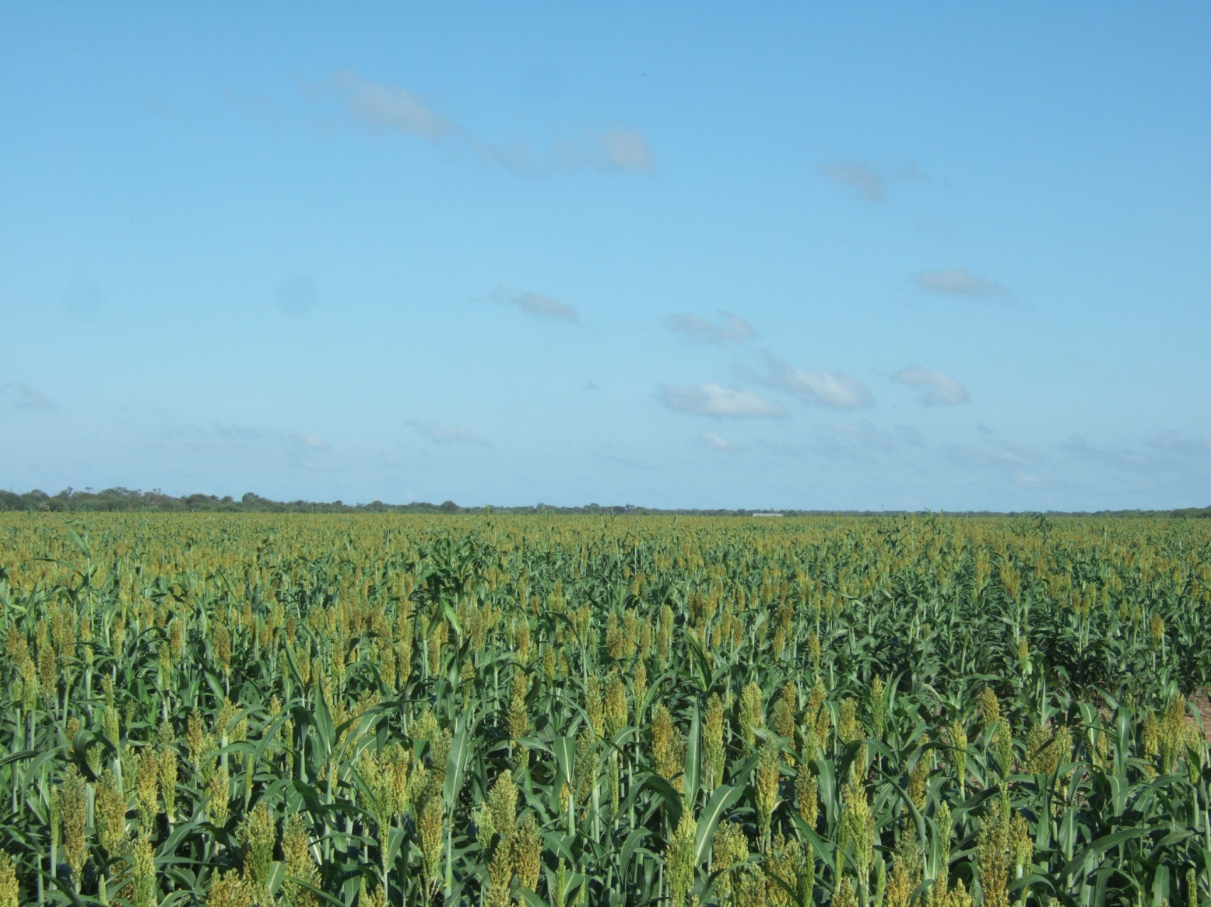
Dryland grain sorghum
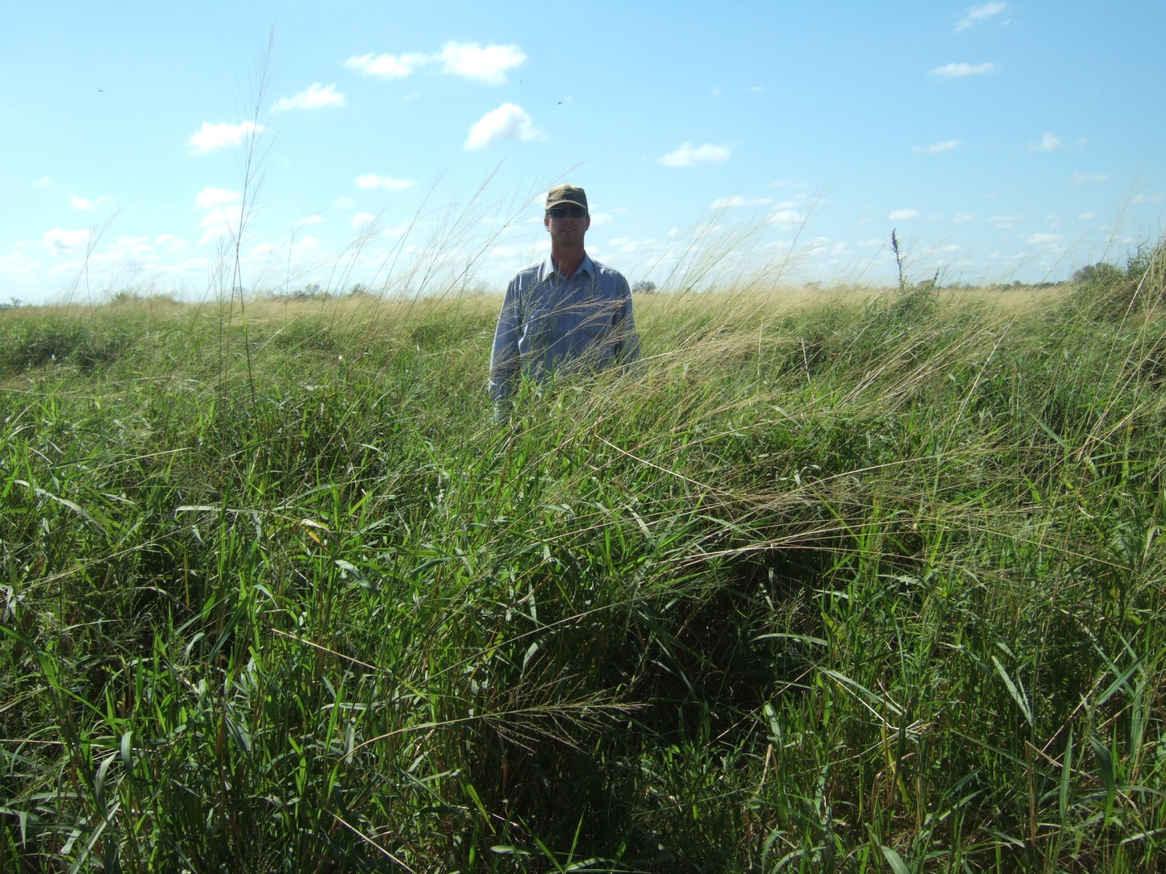

Gatton Panic subtropical improved grass planted in fields. This is excellent feed for mama cows and fattening steers.
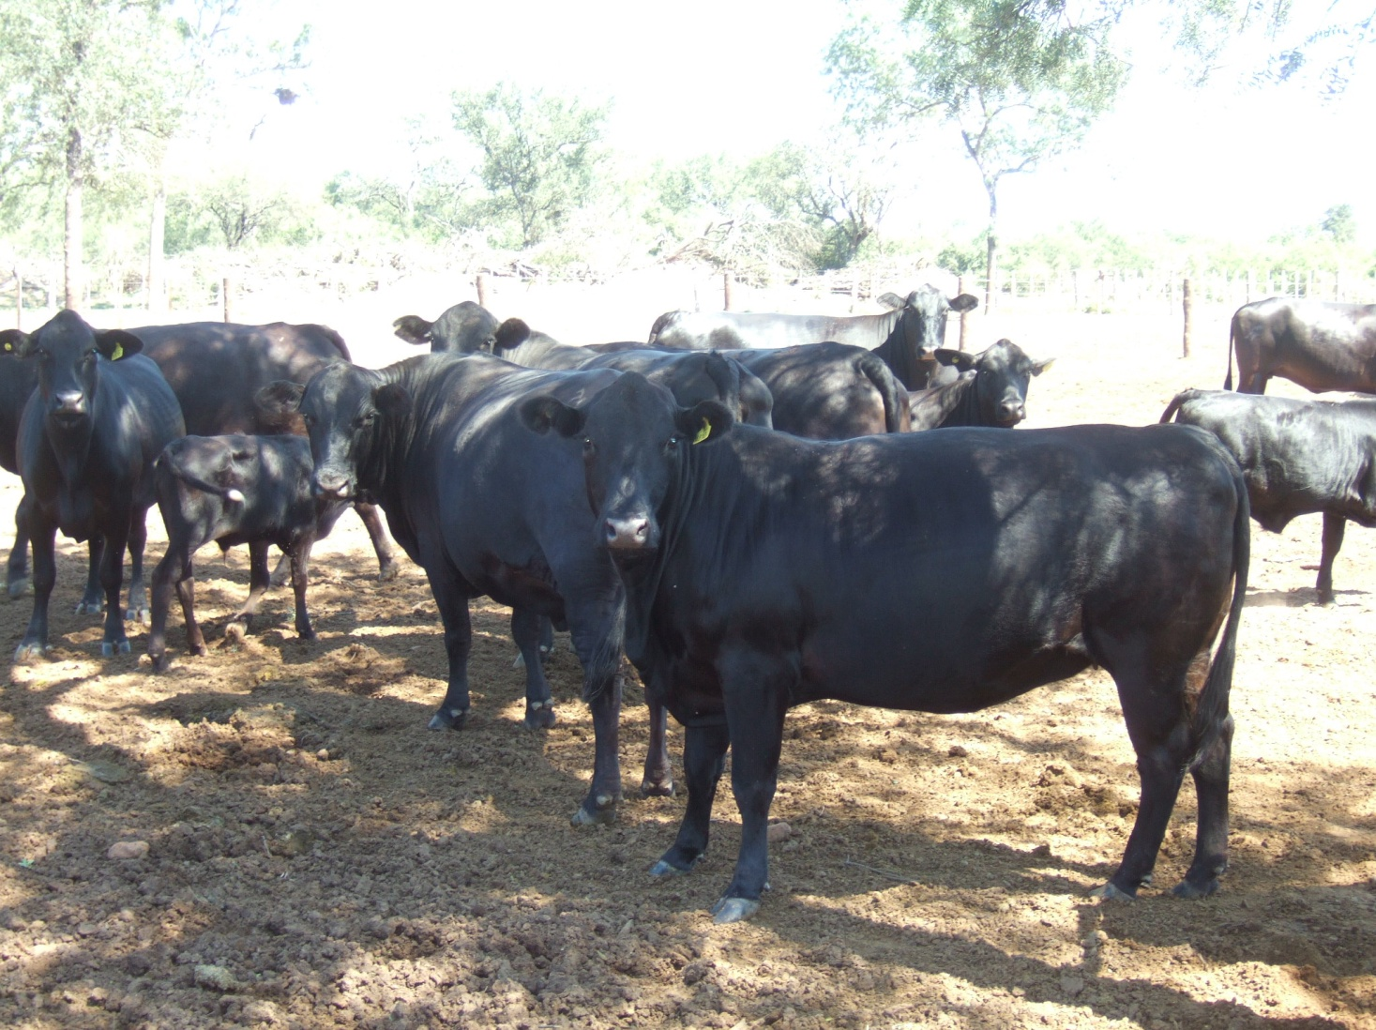

Brangus and Braford cows are necessary for the heat and bugs of this area.
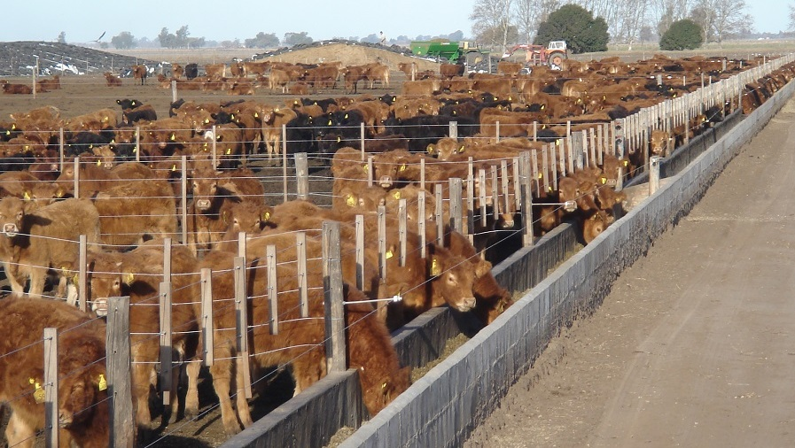
Local Feedyard using locally grown fodder and grain

